The most simple example of concurrency can be summed up in Fig. <$n:figure:basic>

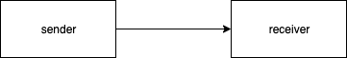

Fig. <$n:figure:basic> Basic Concurrency

